# Lab 9. Creating a Business Process Flow

**Author:** Serge Luca aka “Doctor Flow”

**Updated by**: Dattatray-Patil

**Learning Objectives:** Be able to create a Business Process Flow and a Model-driven app that will consume it.

**Scenario:** You will create a Business Process Flow (BPF) that illustrates how to approve a loan. You will have to create business entities in CDS (Common Data service); these entities will be consumed by the BPF.

**Prerequisites**: During the lab the system will suggest you start a Premium trial subscription; you can accept it.

**Duration :** 25 minutes

## Tasks:

1. Go to the **PowerApps Studio**: [*https://powerapps.microsoft.com*](https://powerapps.microsoft.com/) *or by clicking on the* **PowerApps app** in the **Office 365 App Launcher**:

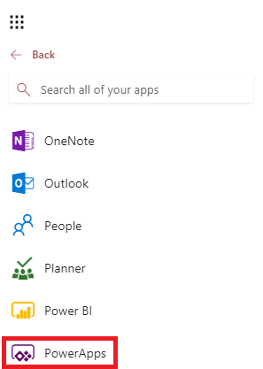

1. If you are working on your own tenant, you first must have **PowerApps Plan 2** in order to be able to create **Model-driven apps**. To check your PowerApps plan, go to the following PowerApps menu:

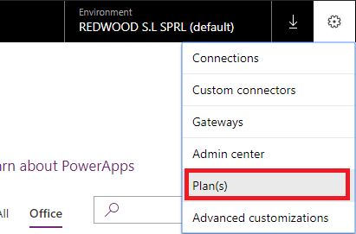

You should get **plan 2**:

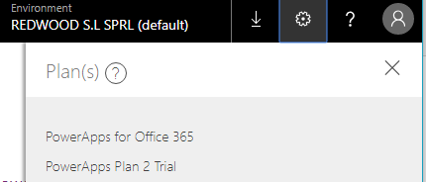

If that is not the case, move to the next step.

1. You can have a free trial version of PowerApps Plan 2. Connect to the [web site](https://docs.microsoft.com/en-us/powerapps/maker/signup-for-powerapps) [*https://powerapps.microsoft.com/en-us/pricing/*](https://powerapps.microsoft.com/en-us/pricing/) to start your trial. When the trial is generated, go to the **PowerApps Admin center**:

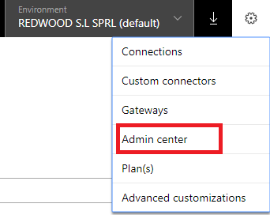

1. Click **New environment**:



1. Fill in the required information:

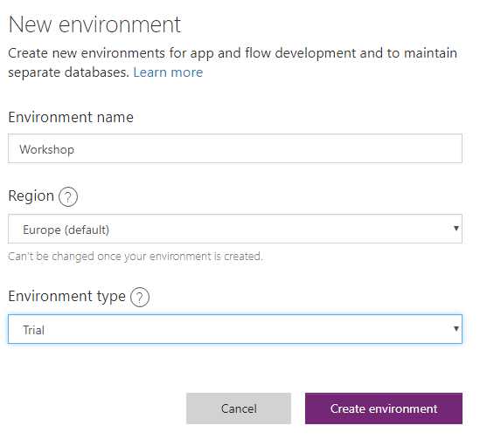

1. Click **Create environment**.
2. The next step (Creating a Database) should not be done if your PowerApps trial account is part of the tenant created by the trainer. You will use the shared database

When requested, click **Create Database**:

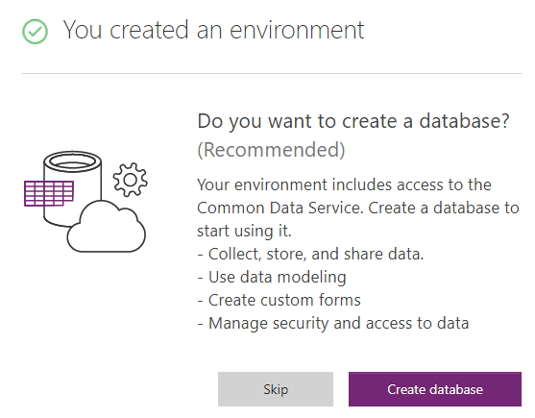

1. If the next screen you will provide more details on the **database settings**:

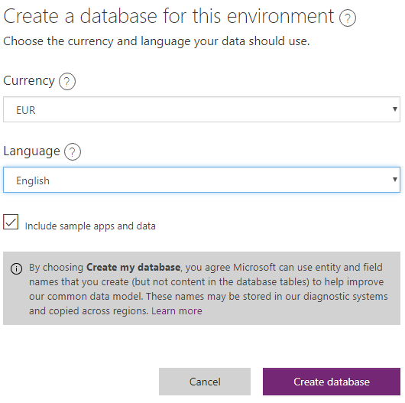

1. Click again on **Create database**.
2. Go to the list of environments and click on the newly created environment, and you will see that the database is being built.
3. Go back to the PowerApps portal [https://powerapps.microsoft.com](https://powerapps.microsoft.com/) and select the new environment:
4. Select the Data Menu and click on **Tables** from Left menu :

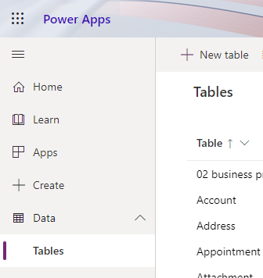

1. Click new **Tables** and create a **New table** called **Loan**:
2. Click **Next**. Click **Add field** to add a new field in this loan entity:

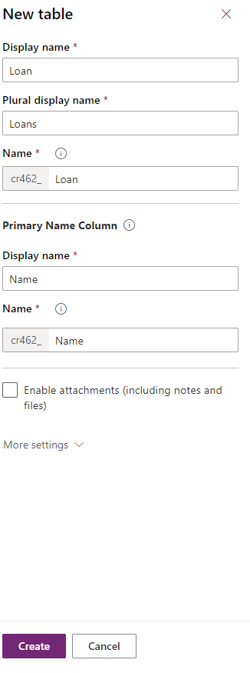

1. Create a field **Amount** (type **Currency**) like shown here:

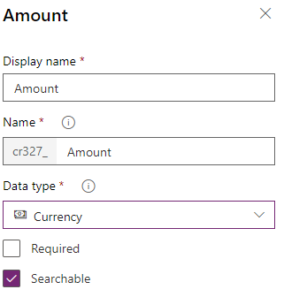

1. Create a field **Account** (type **Customer**):

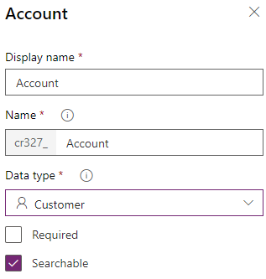

1. Create another field **Approval Status** based on the **Option Set** datatype

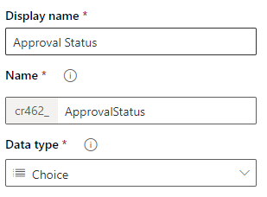

1. Click **Choice** and select **New option set**:

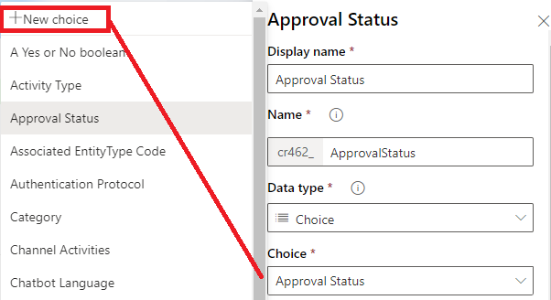

Provide **3 options**: **Approved**, **Rejected**, **Pending**:

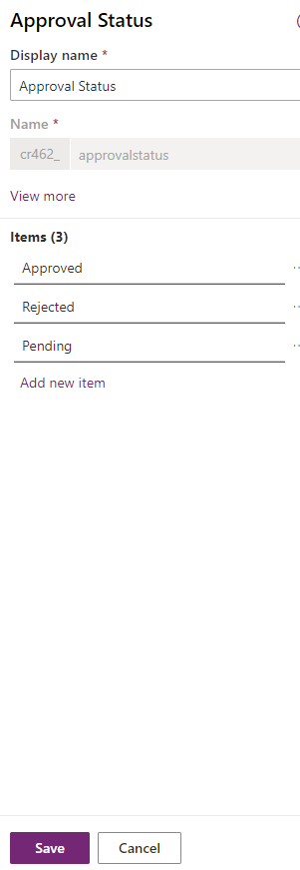

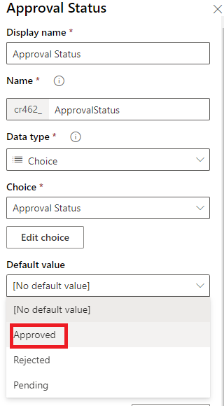

1. Click **Save** and make **Approved** the default value:
2. Click Done.
3. Create a field **Signed** based on the **Yes/No**  type and Yes should be the default value:

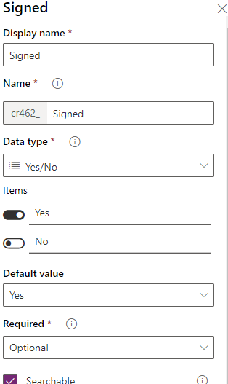

1. Create the last field: **Send Money**:

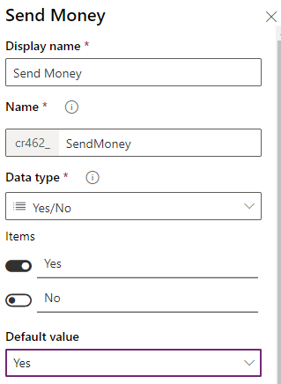

1. Save your field.
2. Save the entity.
3. The following table summarizes your entity Loan fields and settings:

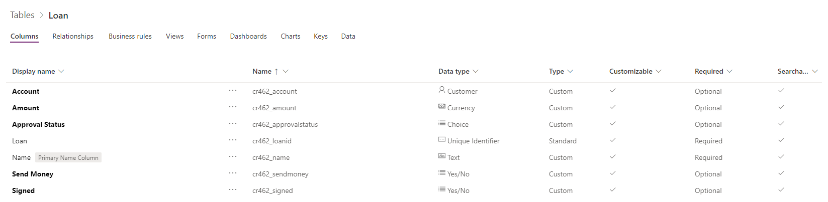

1. Let’s get back to Flow to create a new Business Process Flow. Make sure you are in the good environment.

Click on Flows in the left panel.

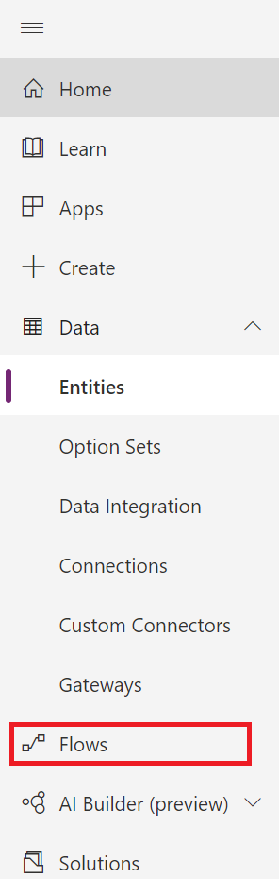

1. Click Business process Flows:

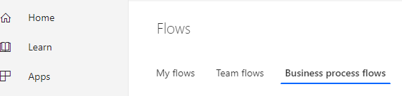

1. Click New and fill in the BPF Display Name and Name; associate it with your loan entity in “Common Data Service entity field:

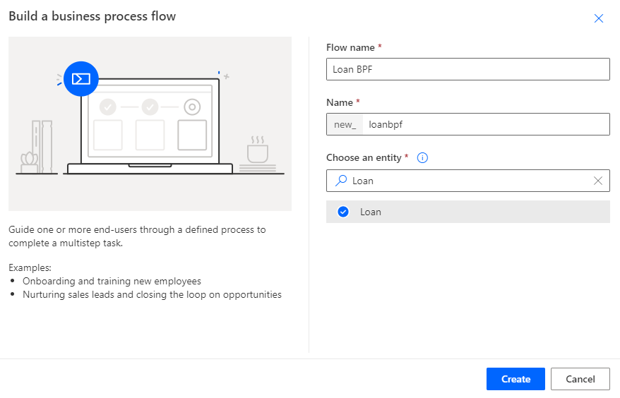

1. Click Next and the BPF designer will show-up:

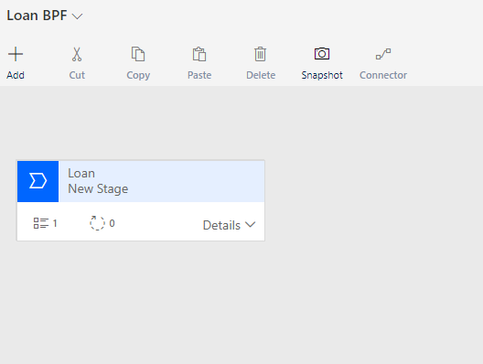

1. Click the **Loan New Stage** and the stage property page, change the display name as **Loan basic info** and click on **Apply**:

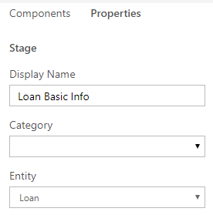

1. In the stage, click the **Detail** and then select **Data Step #1,** In Property Tab name the step Name **Set Account** **Step**, select the **Account** data field, make it **Required,** and click **Apply**.

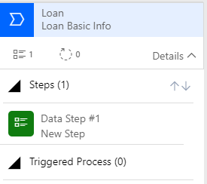

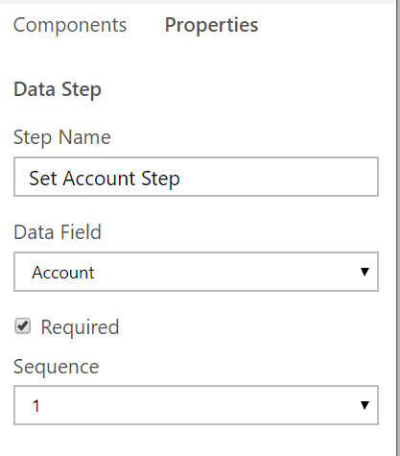

1. Click **Components** to add a new Stage:

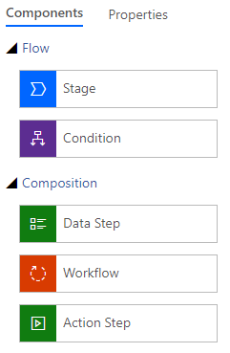

1. Click St**age** and drag & drop a stage next to the current stage:

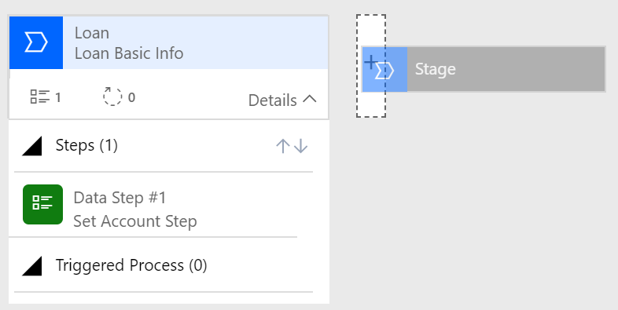

1. Name the Stage **Amount info** and like you did before, edit the data step of the new stage and link it to the Amount Data Field:

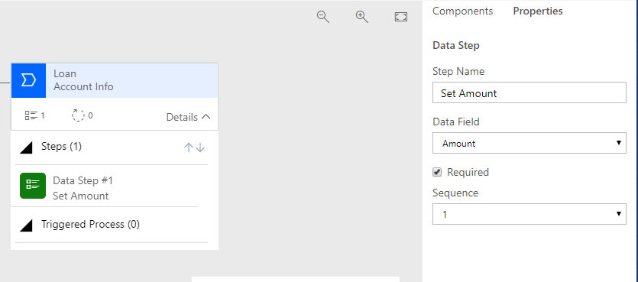

1. Click Apply.
2. Name the stage Loan Amount info.
3. Add a new **Condition Component**:

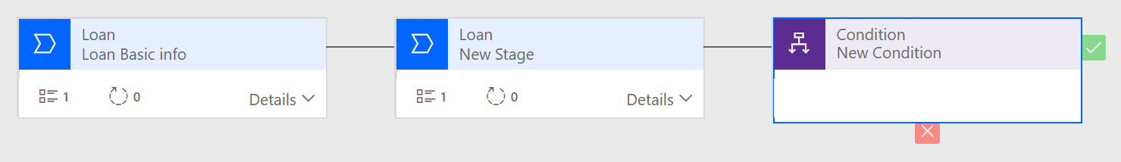

1. and define the rule as follow:

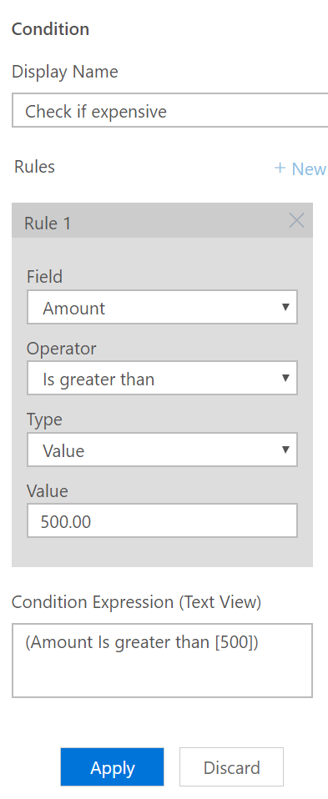

1. Add a **new stage** and name it **Approval**. Name the **data step** **Approval** and select the **field Approval Status** in Green tick section (Drag and Drop in Yes Section). Click Apply once done.

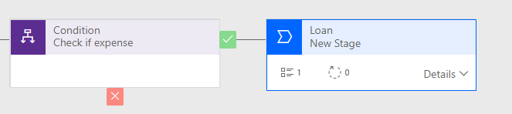

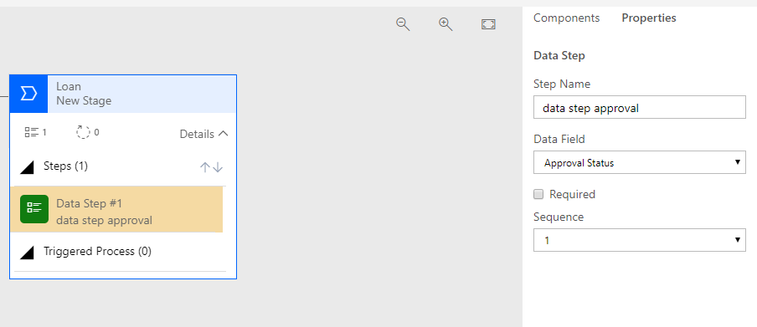

1. Add a **new Condition** and name it **Check if Approved** with the following rule:

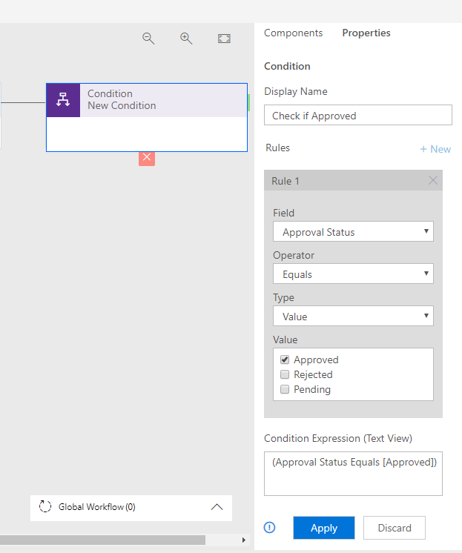

1. Add a **new stage**, name it **Send Money**” and associate the data set with the field **Send Money**. This should again in Yes section.

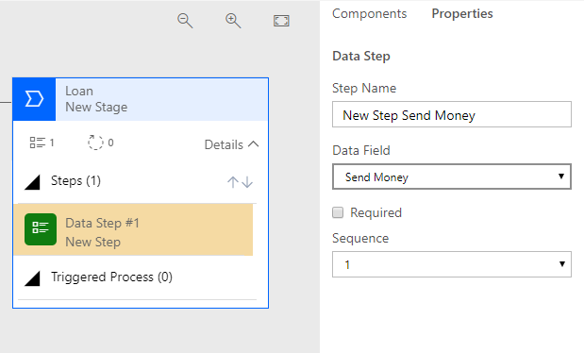

1. Eventually, the Flow should look like this:



1. Click Save
2. Click Validate.
3. Click on Activate and confirm the activation:

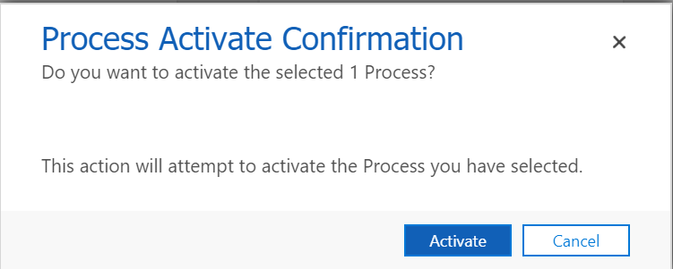

1. Make sure the Business process Flow is activated; go to the Flows menu, and your LoanBPF Flow should be visible in the Business process Flows panel; turn it on if needed.

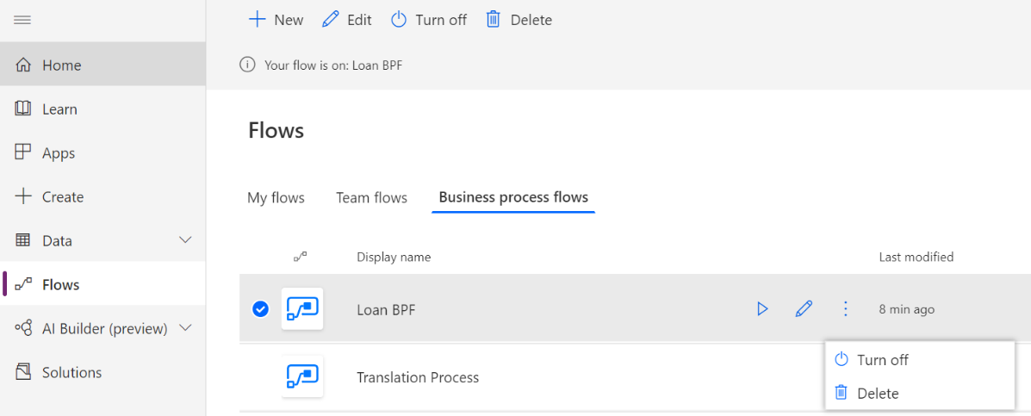

1. Now in order to use the Business Process Flow, we must create a **Model-Driven** Apps associated with our loan Entity. Go to the PowerApps portal and create a new Model-Driven Apps:

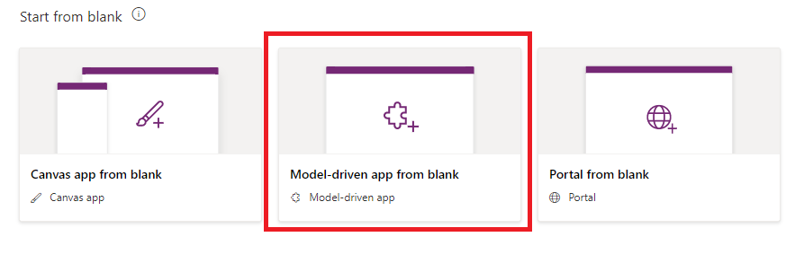

1. Name it Loan:

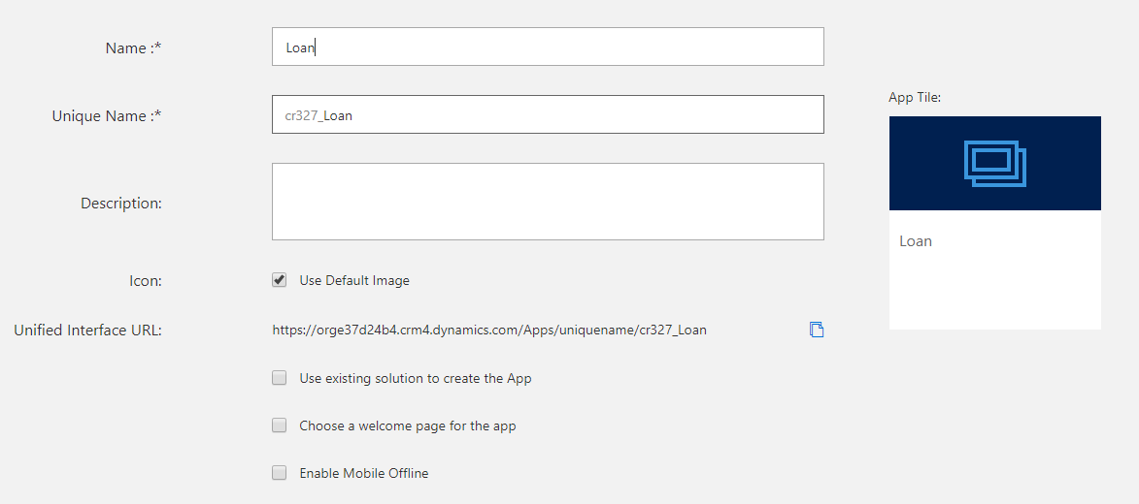

1. Click **Done**.
2. The App Designer will show-up:

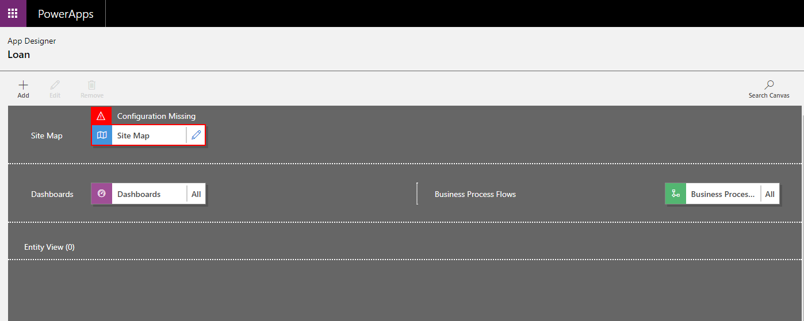

1. Edit the **Site Map** component.
2. Rename the New Area to **Loan Area**.
3. Rename the New Group to **Loan Group.**
4. Rename the Sub Area to **Loan sub-area**.
5. Associate the Loan Subarea with the entity Loan:

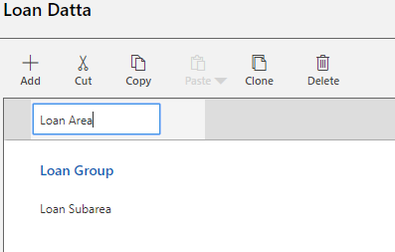

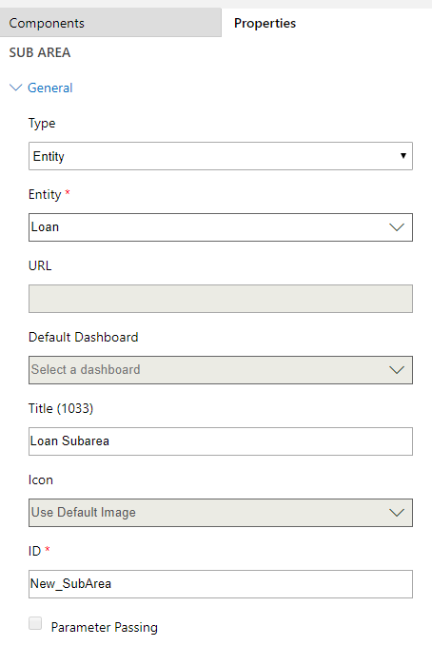

1. Click Save and Close, and you will be redirected back to the App Designer screen.
2. In the Designer, Click on **Entities**:

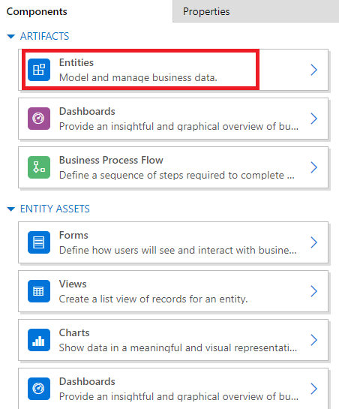

1. In the list of entities, **loan** has already been selected, but you still must select **Loan BPF**. This is important for the internal working of BPF. This extra step might be automated in the future.
2. Click Save.
3. Click Publish.
4. Click Play.
5. You should see the following application:

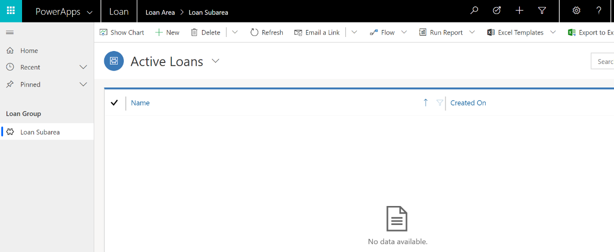

1. If you click **New**, a new loan will be created. Set the Name to **loan for a new car** and save it:

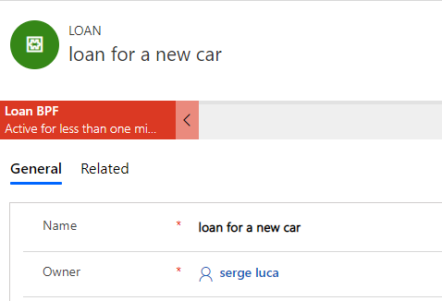

1. Click on the stage **Loan Basic Info;** here, you need to define a **new account**:
2. A new popup will be visible, click on **Accounts** to create a new account.:

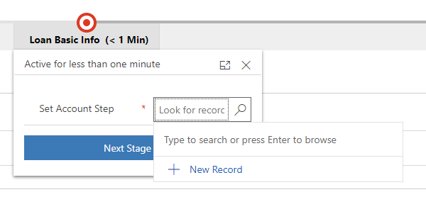

1. Click **New Record** to create a new account, call it **Redwood** and click **Save and Close**:

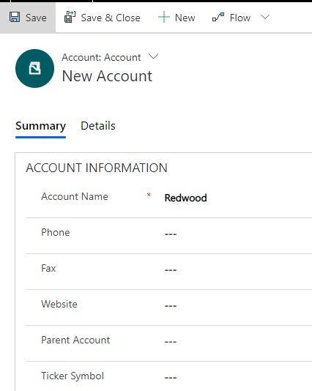

1. In the Flow, go to the next stage:

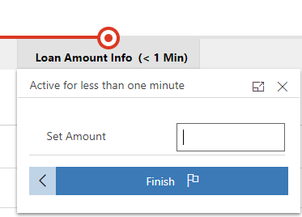

1. As you can see this is supposed to be the last step by default; however, if you add an amount higher than 500, you will see additional steps:

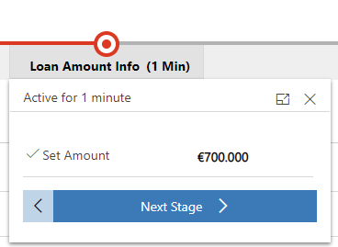

1. Click on **Next stage** until the end of the process.
2. Click on **Home** to see your list of entities:

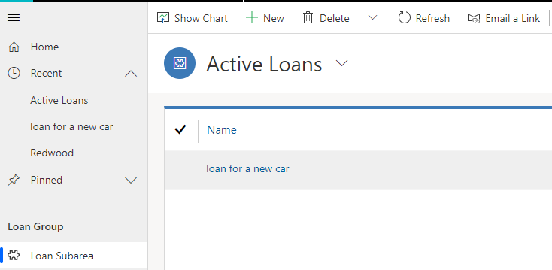

1. If you click on **loan for a new car**, the whole process will show up:

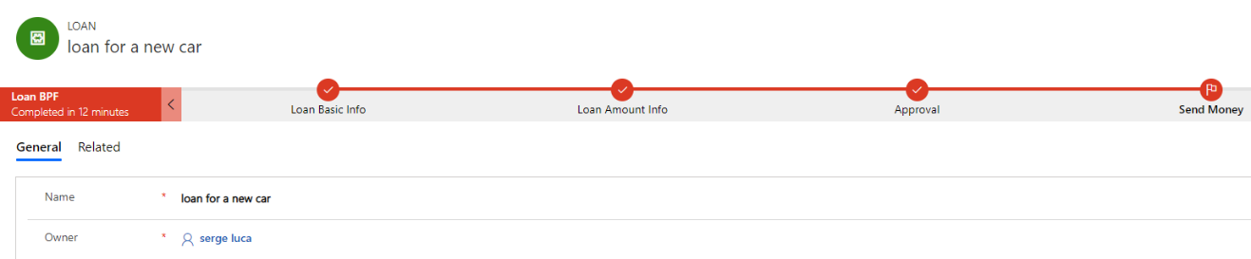

1. Congratulation for your first Business Process Flow!

**We need your feedback**

Do you want to report an issue or to suggest something? We need your feedback: <https://github.com/Power-Automate-in-a-day/Training-by-the-community/issues>